

INFORMATICS INSTITUTE OF TECHNOLOGY

In Collaboration with UNIVERSITY OF WESTMINSTER

**6MARK027C  
Digital Marketing, Social Medial and Web Analytics**

**Coursework II**

Name: Muhammad Areeb Niyas

20200129 | w1809939

Word Count - 2774

Module Leader: Mr Prassanna Pathmanathan

Submitted in partial fulfilment of the requirements for the BSc(Hons) in Computer Science degree at the University of Westminster.

**Date: April 2024**

**Table of Contents**

List of Tables iii

List of Figures iii

PART A 1

Task 1: Concept of Events 1

Function and Role of Google Analytics 4 Events 1

Event Properties and User Interactions 2

How it was applied to the microsite of Umaria Sinhawansa 2

Task 2: Steps to Create GA4 Account and Connect with Microsite 6

Task 3: HTTP Cookies 8

Definition 8

Problems Tackled by HTTP Cookies 8

Stateless Web and HTTP Cookies 8

Limitations of Cookies 9

Diagram 10

Task 4: Microsite Reports 11

01 Users by Browser Over Time 11

02 Views by page title and screen class over time 12

03 Sessions by ‘session default channel grouping’ 13

04 New Users by ‘First user default channel grouping’ 14

05 User Engagement (overview) 15

06 User Retention (overview) 17

07 Users by City 18

08 Returning Users by Device Category 19

09 New Users by Screen Resolution 20

Task 5: KPI 21

KPI Relevant to Microsite 21

Justification of KPI based on analysis from Task 4 21

KPI Sections and Justifications 22

Task 6: Email Marketing 23

PART B 24

Task 7: Data Misinterpretation 24

Challenges in Calculation of the Number of Unique Visitors to a Website 24

Differences between “visitors”, “new visitors” and “unique visitors” 24

Challenges of Measuring Session Duration and Quantifying the Amount of Time Spent on an Individual Web Page 25

The ‘hotel problem’ 26

Some Problems Related to Data Misinterpretation in Web Analytics 27

References I

# **List of Tables**

Table 1: Event properties and user interactions 2

Table 2: How cookies tackle problems 8

Table 3: Limitations of cookies 9

Table 4: KPI sections and justifications 22

Table 5: Differences between visitors, new visitors and unique visitors 24

Table 6: Problems of session duration and the amount of time spent on one web page 26

Table 7: Hotel problem analogy 26

Table 8: Problems related to data misinterpretation in web analytics 28

# **List of Figures**

Figure 1: Events in microsite 3

Figure 2: Form submission 4

Figure 3: Clickable events 4

Figure 4: Event page_view 5

Figure 5: Measurement ID from stream 6

Figure 6: Settings on Google Sites 7

Figure 7: Analytics integration with micro-site 7

Figure 8: Key Stages in HTTP (self-composed) 10

Figure 9: Report 01 - Users by browser over time 11

Figure 10: Report 02 - Views by page title and screen class over time 12

Figure 11: Report 03 - Sessions by ‘session default channel grouping’ 13

Figure 12: Report 04 - New users by ‘First user default channel grouping’ 14

Figure 13: Report 05- User Engagement (overview) 15

Figure 14: Report 06 - User Retention (overview) 17

Figure 15:Report 07 - Users by City 18

Figure 16: Report 08 - Returning users by device category 19

Figure 17: Report 09 - New users by screen resolution 20

Figure 18: Email flyer 23

# PART A

## Task 1: Concept of Events

The concept of events in Google Analytics 4 refers to how user interactions and specific actions a user performs on a website or app can be tracked and captured. GA4 collects all data as events and the 4 types include: custom events, automatically collected events, enhanced measurement events and recommended events (Duncan, 2023).

Some examples of Google Analytics 4 include:

* Page View – tracking when a page is loaded.
* Click – recording when a link or button is clicked.
* Form Submit – record when a user submits a form.
* Scroll – monitor how far a user scrolls down a page.

### **Function and Role of Google Analytics 4 Events**

If a person is interested in tacking the interactions with the users and leads of your website then using events is vital (Holmes, 2023). It allows the gain of valuable insights of how users interact with your website which can be used to improve the pages, length, user experience and content efficiently (Vemmanna, 2022).

Some of the key roles include **understanding and analyzing consumer behavior** as the valuable insights gained through events such as the micro interactions between the user and the components of a website can be used to optimize the website based on the analysis. Also, **enhancing user experience** based on the pain points identified using the events (Billington, 2023). In addition, **effectiveness of marketing campaigns** could be identified by measuring and evaluating the conversions such as submitting forms, making a purchase, subscribing for newsletters before and after the campaign (Colarossi, 2024).

### **Event Properties and User Interactions**

|  |  |
| --- | --- |
| Property Name | Relationship with User Interaction |
| Event Name | Used to identify the type of event related to the user interaction. |
| Event Category | Provides information about the category of user interaction (such as page and form). |
| Event Action | Dictates the type of interaction by the user (submit, scroll and click). |
| Event Parameters | Provides contextual data such as form field values and page name and session duration for the user behavior. |

Table 1: Event properties and user interactions

### **How it was applied to the microsite of Umaria Sinhawansa**

The concept of GA4 events was applied in multiple ways and will be explained using below illustrations.  
  
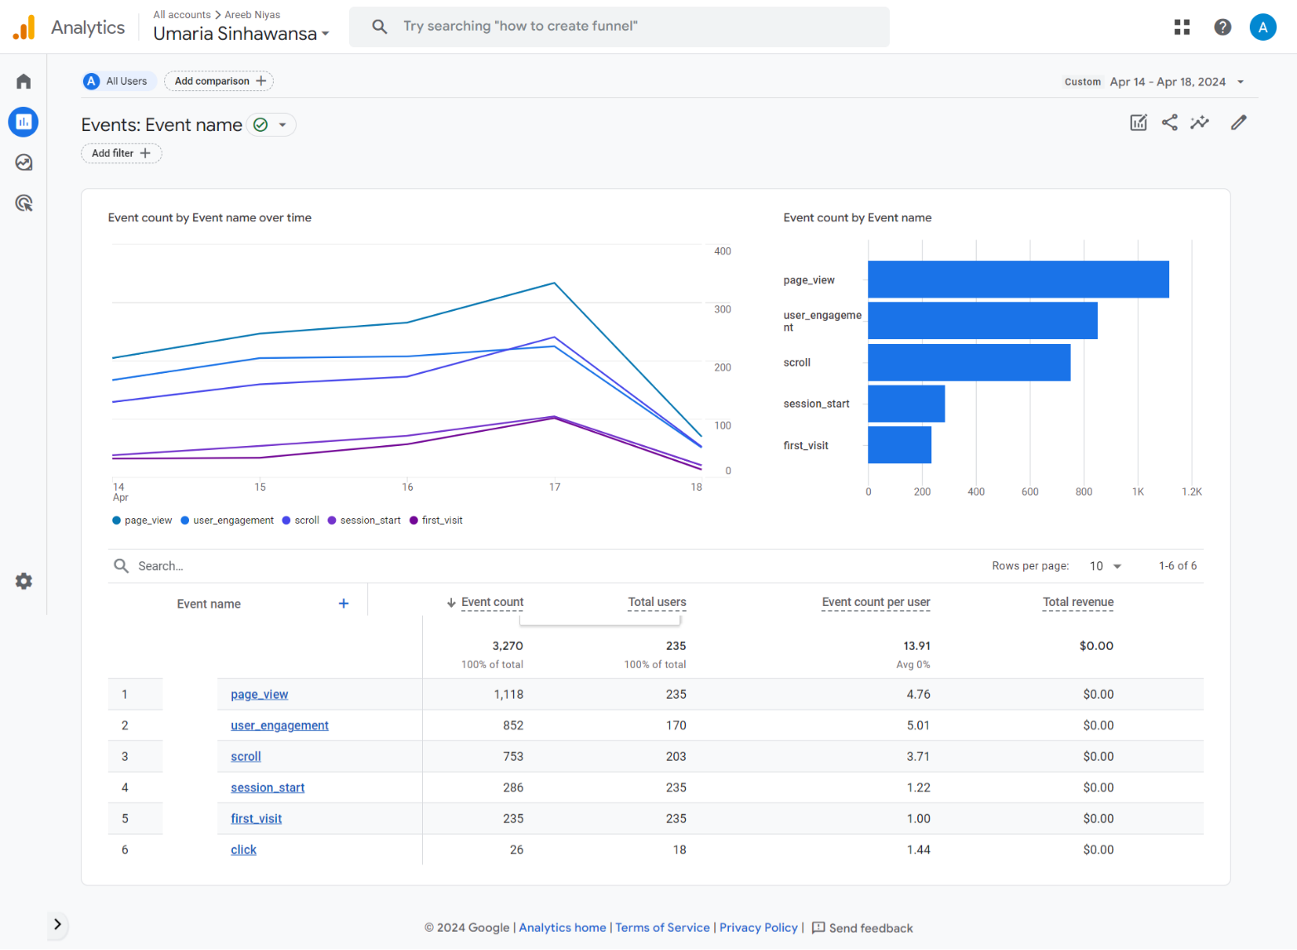

Figure 1: Events in microsite

The above figure shows GA4 events such as page_view, click and scrolling which provides valuable insights such as how many users clicked a particular element and scrolled through a page. With this information, optimization such as more visible and UI friendly clickable elements could be modified to increase the average clicks and more engaging content could be added to increase the scroll.

Also, by having form submission events as shown below, could be used to calculate conversion rates. Click events such as ‘Find out more’ buttons and ‘Connect’ and scroll events were also integrated.

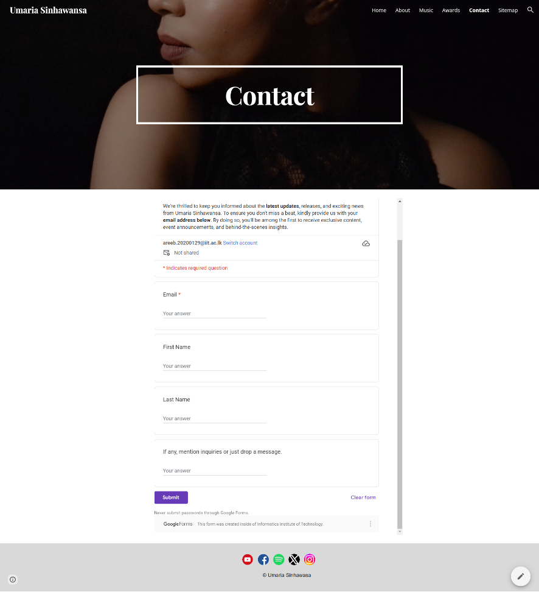

Figure 2: Form submission





Figure 3: Clickable events

To dive into deeper insights, the below figure shows a more detailed representation about the page_view which shows the average time a user has spent on each page and the bounce rate can be calculated. So based on these statistics, more optimization could be done to the sites with lower average times such as the ‘music’ page.

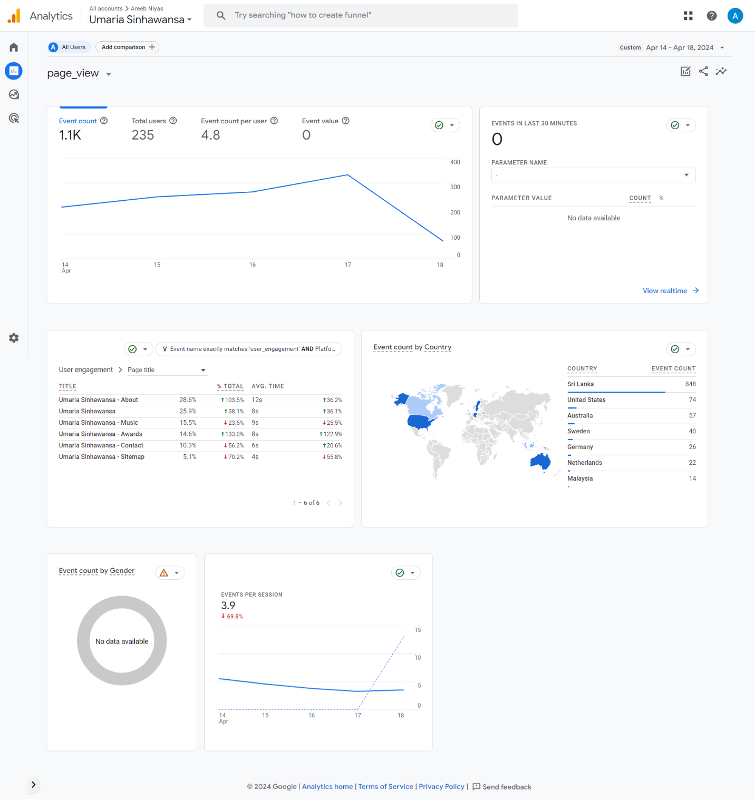

Figure 4: Event page_view

## Task 2: Steps to Create GA4 Account and Connect with Microsite

Step 1 – Go to the Google Analytics website and sign in using your Gmail account. For first time users, click ‘Start Measuring’.

Step 2 – Create an account by adding account name and other sharing settings. Then create a property by providing details such as name, country, currency and time zone.

Step 3 – Select the data collection stream (web or mobile) where “website” was chosen for this scenario.

Step 4 – Add the website URL following the previous step (<https://sites.google.com/iit.ac.lk/umaria/)> and click on ‘Create Stream’ which will generate the web stream details.

Step 5 – Copy Measurement ID from the previous step as shown below.

Figure 5: Measurement ID from stream

Step 6: Open your microsite in Google Sites and click on settings as shown below.

Figure 6: Settings on Google Sites

Step 7: Select the Analytics tab and enable analytics using the toggle and then paste your previously copied Measurement ID as shown below.

Figure 7: Analytics integration with micro-site

Task 3: HTTP Cookies

### **Definition**

HTTP cookies are small blocks of data created by a web server based on the user user’s behavior on a website such as interactions. It is stored in the user’s device by the user’s web browser (Biselli, Utz and Reuter, 2024). They allow storing stateful information by sending and receiving HTTP requests which help browsers manage sessions, remember specific user behavior and allow personalization (Barth, 2024).

### **Problems Tackled by HTTP Cookies**

|  |  |
| --- | --- |
| Problem | How Cookies Tackle Them |
| Managing user sessions | Help websites remember user sessions, maintaining login status and preferences across pages (Kahrer, 2022). |
| Personalization | They enable personalized experiences by storing user preferences, language settings, and customization choices (Bilal, 2023). |
| Monitoring user behavior and analytics | Websites use cookies to track user behavior, analyze site traffic, and gather data for improving content and user experience (Zawadziński, 2023). |
| Authentication | Cookies aid in user authentication, allowing websites to verify and manage user logins securely (Gupta, 2024). |

Table 2: How cookies tackle problems

### **Stateless Web and HTTP Cookies**

HTTP requests and responses are sent and received between the web server and web browser and each request is stateless (independent). Therefore, by nature it does not capture any information about the user or their interaction (Subham, 2023). However, this raised challenges especially for e-commerce websites and applications that require stateful sessions. So address this challenge, HTTP cookies were introduced to allow servers to recognize and remember users and their behavior across multiple requests by storing information using cookies on the user’s device (Koishigawa, 2021).

### **Limitations of Cookies**

|  |  |
| --- | --- |
| Limitation | Explanation |
| Storage and Lifespan | Limited 4096 byte storage and short life spans make it hard to save large data over a longer period (Rathore, 2012). |
| Security Concerns | Vulnerable to exploitation by malicious users for unauthorized access (Roomi, 2021). |
| Privacy Concerns | Cookies can track users' browsing habits and collect personal data without explicit consent raising privacy issues (Kumar, 2022). |

Table 3: Limitations of cookies

### **Diagram**

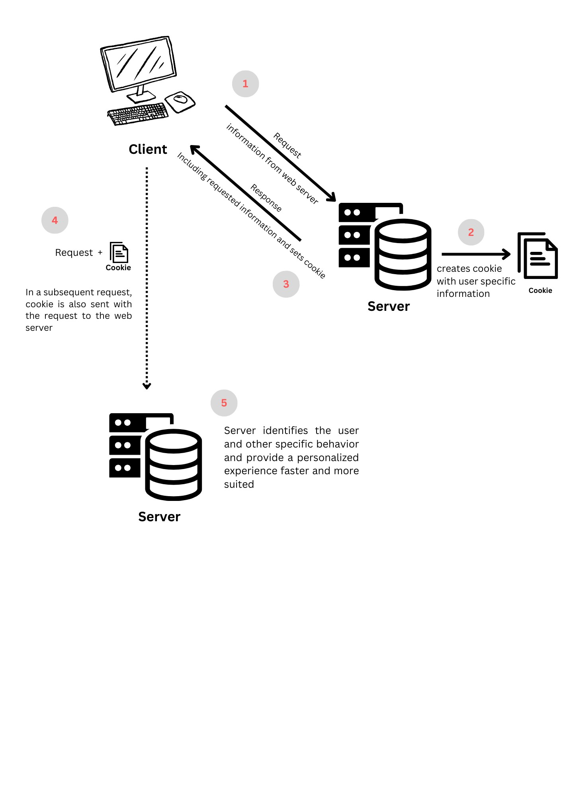

Figure 8: Key Stages in HTTP (self-composed)

## Task 4: Microsite Reports

A period of 5 consecutive days ranging from 14th April 2024 to 18th April 2024 was chosen to generate traffic to the microsite about Umaria Sinhawansa. The following reports and findings were gathered.

### **01 Users by Browser Over Time**

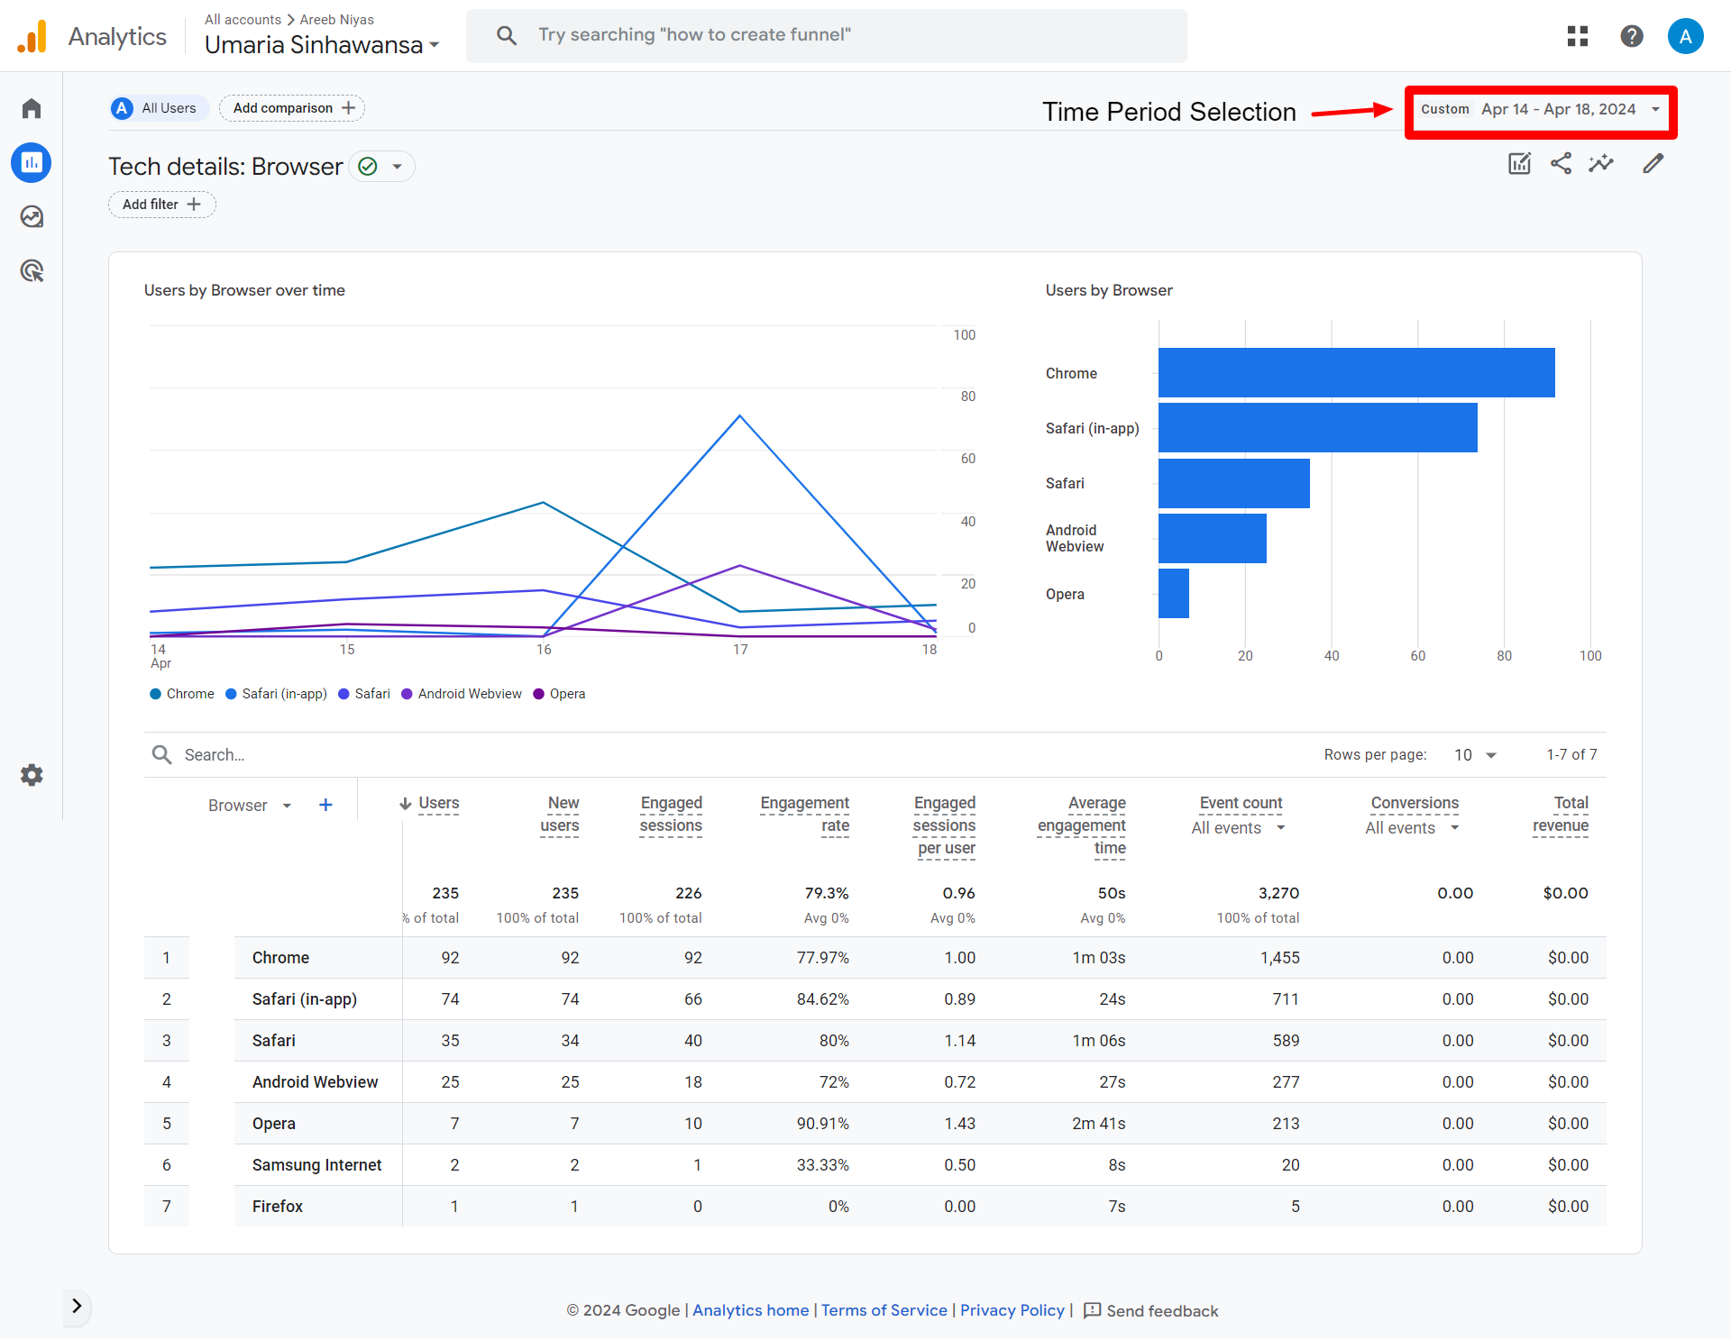

Figure 9: Report 01 - Users by browser over time

**Findings:** From the 235 people who visited the site, the majority of the people used Safari when you combine both Safari and Safari (in-app), it totals to 109 users whereas Chrome users were 92. This suggest that most users used apple products. On the other hand, Opera had the highest engagement rate of 90.91% and average engagement time of2m and 41s.

### **02 Views by page title and screen class over time**

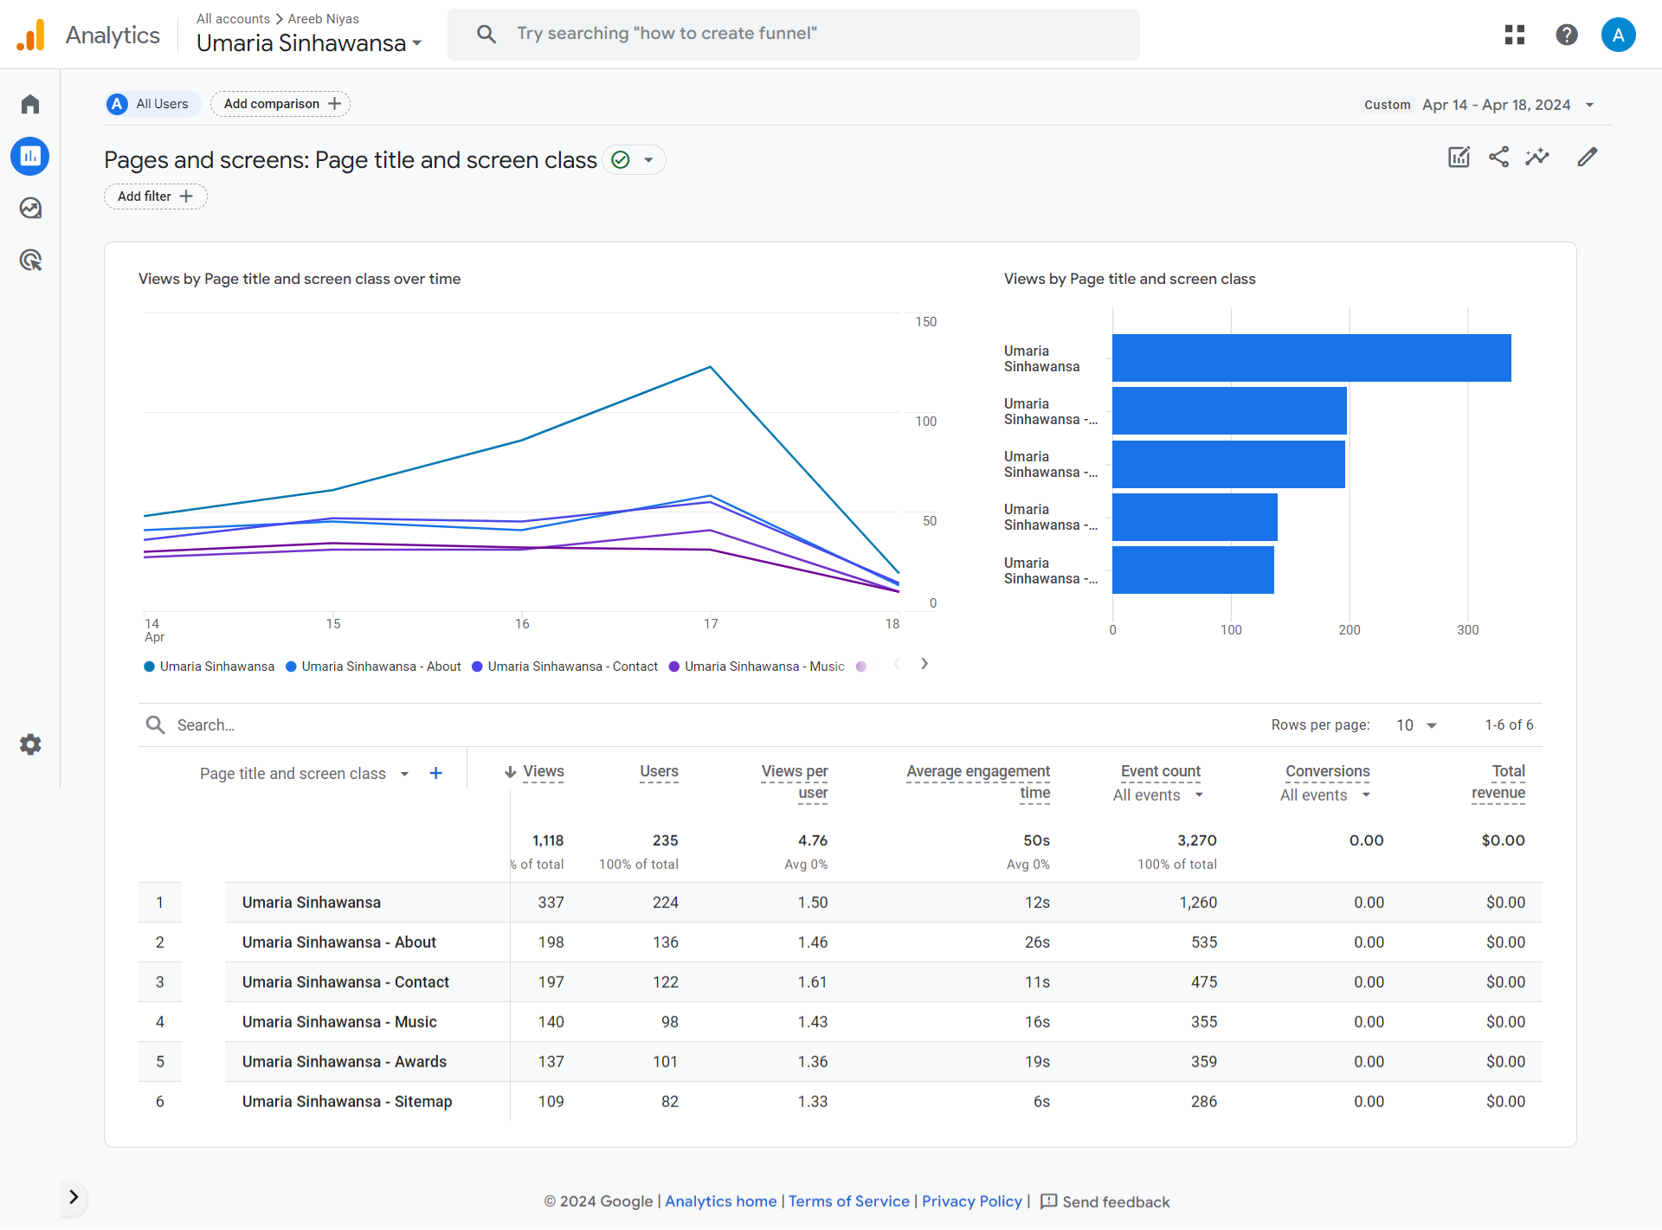

Figure 10: Report 02 - Views by page title and screen class over time

**Findings:** A total of 6 screen classes were available in the microsite where the home page ‘Umaria Sinhawansa’ had the most total views of 337 out of the total 1118 views. The ‘About’ and ‘Contact’ page came hand in hand with 198 and 197 views in total. Also, low average engagement time was noticed in the landing, contact and sitemap pages of 12s, 11s and 6s respectively. The content and navigation could be optimized in these pages and increase the overall user experience to increase the average engagement time.

### **03 Sessions by ‘session default channel grouping’**

Figure 11: Report 03 - Sessions by ‘session default channel grouping’

**Findings:** Majority out of the 235 users arrived at the site using ‘Direct’ channel (147 out of 235). The number of engaged sessions and average engagement time per session is higher for the ‘Direct’ channel (50s) as well compared to the Organic Social channel which only 21s. This suggests that users who received the site URL directly have been the most effective. However, the Organic Social channel had a slightly higher engagement rate of 81.4% which suggests that those users were more curious about the microsite.

### **04 New Users by ‘First user default channel grouping’**

Figure 12: Report 04 - New users by ‘First user default channel grouping’

**Findings:** Majority of new users arrived directly to the website which is 147 out of 235 whereas Organic Social via email and Instagram is 87 users. This suggests that the social media marketing campaigns could be improved.

### **05 User Engagement (overview)**

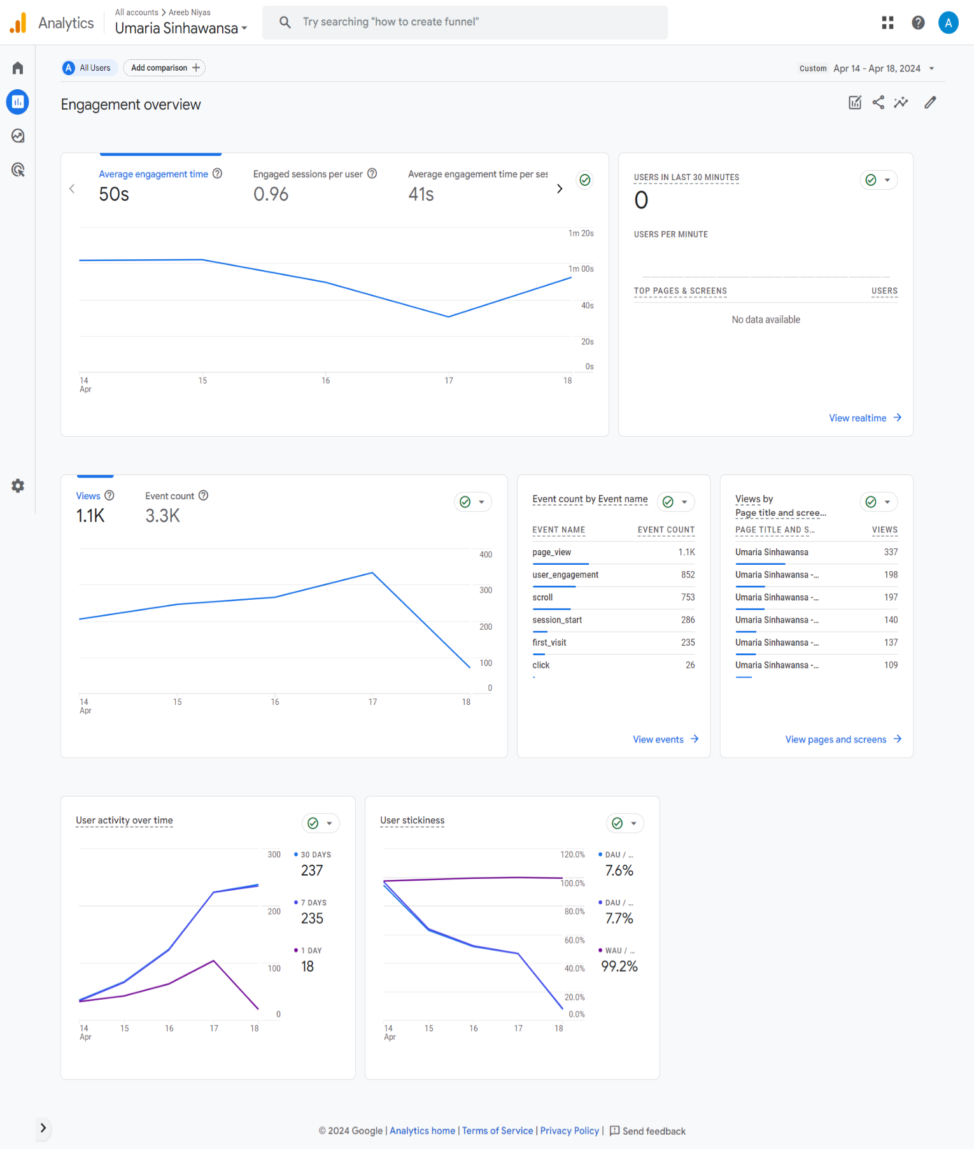

Figure 13: Report 05- User Engagement (overview)

**Findings:** The 1st chart in the above report shows that the average engagement time is 50s with 0.96 engaged sessions per user. A decline in engagement was also noticed after day 2 upto day 4 but a gradual increase after day 4. The second line chart illustrates a total of 1.1K views and 3.3K event counts with a gradual increase till day 4 and a rapid decline on the last day. The event count by event name is also displayed along with the views by page title where the home page had the greatest number of views. The last two graphs demonstrate the user activity over time and user stickiness where the user activity increased over time but the user stickiness reduced constantly so it could be improved.

### **06 User Retention (overview)**

Figure 14: Report 06 - User Retention (overview)

**Findings:** A total of 235 new users were gathered with a returning of only 26 users which is only 11%. Therefore, repeat users could be improved. The other user retention and engagement graphs shows a rapid decline over a period of 5 days which implies that there is an issue in retaining users and user engagement within your microsite and should be looked into like the overall UX, lack of engagement, navigation and technical issues (like load times).

### **07 Users by City**

Figure 15:Report 07 - Users by City

**Findings:** This report shows that 58% of the users were from city Colombo and 31 users had a value of not set which indicates that there IP could not be mapped. So afterwards, Sri Jayewardenepura Kotte which is the capital of SL had the most users followed by Melbourne, Weligama and Frankfurt of 13, 11 and 4 users respectively. The engagement rate was noticed to be higher from cities outside SL.

### **08 Returning Users by Device Category**

Figure 16: Report 08 - Returning users by device category

**Findings:** This report shows that most of the returning users were mobile users over time where 10% of the total mobile users returned and 15% of web users were returning users. The overall return rate has massive room for improvement.

### **09 New Users by Screen Resolution**

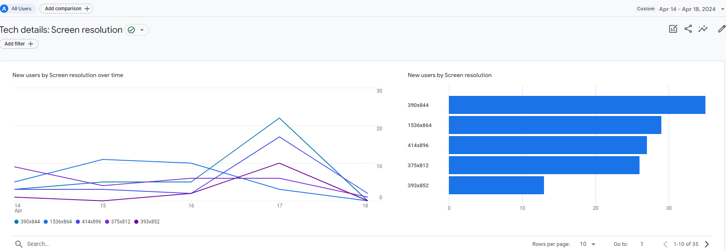

Figure 17: Report 09 - New users by screen resolution

**Findings:** This report shows the screen sizes where the majority of users using a device of 390x844 pixels and only 29 users using the standard PC resolution of 1536x864 pixels. This directly links to the fact that majority of the users acquired were mobile users.

## Task 5: KPI

### **KPI Relevant to Microsite**

Increase user retention rates of mobile and web users that visit the microsite.

### **Justification of KPI based on analysis from Task 4**

According to the ‘Returning Users by Device Category’ report it was noticed that only 19 out of 190 web users, which is 10% were returning users and 7 out of 46 desktop users which is 15% returned to the website.

According to the industry standard benchmark it is considered best to aim for at least 25% or more for retention rates (Pearson, 2021). It is proved that improving retention rates by just 5% with the effort of optimizing and acquiring customers strategically could return significant results and returns (Tessitore, 2023).

### **KPI Sections and Justifications**

|  |  |
| --- | --- |
| Brief Description | Increase returning users to the website to improve user retention rates. |
| Exact Change (%) | Increase overall user retention rate by **15%** for both web and mobile users. So that the returning mobile users come up to a total of 25% and returning web users increase to a total of 30%. According to the benchmarks and industry standard mentioned earlier this could be considered a realistic and effective target. |
| Time Period | **90 days.** This duration allows the optimization effort to take place and monitor timely concerns any adjustments.  Retention rates are usually measured over a 30+ days or 90+ days period (Pearson, 2021). |
| Action to be Taken | * **Improve the overall UX** of the microsite by making it more engaging and easier to navigate. Also, optimize the content and UI to make it more interesting and appealing. * **Personalized email marketing campaigns** could be conducted to the ‘Subscribed’ users who filled the form on the contact page. By making personal content, it would make interested users feel important and return to the microsite. |
| Monitoring Period | **Weekly**. This helps monitor the progress efficiently for the total of 90 days which includes 6 weeks of monitoring in total to make changes and analyze if there is an impact from the changes. |

Table 4: KPI sections and justifications

## Task 6: Email Marketing

Footer

Body

Logo and Header

CTAs

Figure 18: Email flyer

# PART B

## Task 7: Data Misinterpretation

### **Challenges in Calculation of the Number of Unique Visitors to a Website**

* **Tracking users across multiple devices** – One user may have many devices with them which may incorrectly show unique visitors. On the other hand, another user may use a shared device which will show a lower unique visitor count (Juviler, 2023).
* **Blocking and deletion of cookies** – Clearing and blocking cookies limits user experience, faster logins and access to websites. This makes it difficult to calculate unique visitors because without cookies requests become stateless so in the information wont be passed and received with any storage disabling to track unique visitors (Hanko, 2022).
* **IP Address Challenges** – IP addresses could change arbitrarily causing one user to be considered unique in more than one instance (Melhuish, 2023).

### **Differences between “visitors”, “new visitors” and “unique visitors”**

|  |  |  |
| --- | --- | --- |
| Visitors | New Visitors | Unique Visitors |
| Refers to the total number of people who visited the site for a period of time whether it maybe a returning visitor or a new visitor visiting the site for the first time (Stojanovic, 2022)**.** | If the visiting user doesn’t have a prior cookie, they could be considered a new visitor. This refers to the people visiting a site for the first time within a specific time frame (Stojanovic, 2022). | Refers to distinct people that visit a website for a given time frame and no matter how many times they visit they are counted as only one unique visitor. For example, a person visiting a website 3 times a week will be counted as a single unique visitor but 3 new visitors (Campbell, 2021). |

Table 5: Differences between visitors, new visitors and unique visitors

### **Challenges of Measuring Session Duration and Quantifying the Amount of Time Spent on an Individual Web Page**

|  |  |
| --- | --- |
| Challenge | Explanation |
| Different Browsers, Devices and Networks | Various browsers, devices or network latencies can have their own limitations and speeds which affect load times of a page or how long it takes for interactions with certain elements of a webpage. All this could lead to in accurate measurement of session duration and time spent on a web page (Ogunmola and Kumar, 2020). |
| Idle Tabs & Windows | User inactivity or just leaving a tab open makes it challenging for analytics tools to determine real interactions and lead to overestimation of session duration and time spent (Paruch, 2023). |
| Blocking JavaScript | Some users may set their privacy settings to disable tracking that block cookies or manually disable JavaScript or use external tools such as Adblockers which blocks JavaScript which is responsible for tracking and monitoring time spent on pages. This would lead to inaccurate measurements (Saric, 2020). |
| Single Page Visits | Some tracking tools rely on page transitions to record session duration. Visting a single page sometimes leads to recording session duration as zero even if user is engaging with the one page. So this makes it difficult to determine the actual duration (Paruch, 2023). |
| Multiple Device Usage | Users tend to switch between their mobile phone and PCs frequently to access the same website. This poses a challenge to track the same user and link interactions from different devices to one user journey. This leads to incomplete and disintegrated data (Ogunmola and Kumar, 2020). |
| Usage of Multiple Tabs or Windows | Linking interpretations and analytics across multiple tabs is considered difficult for analytics tools as its difficult to identify the presently active tab during multiple switching leading to miscalculated data (Clark, 2023). |
| Misleading Interpretations | Users may sometimes spend longer periods on a page passively viewing the data by analyzing the content or taking down notes. So, user engagement doesn’t always link to session duration and amount of time spent could be through passive viewing as well. Session timeouts due to this could lead to misleading data (Ogunmola and Kumar, 2020). |
| Time Zone Differences | Time zone variations from contributed users across multiple countries might cause inconsistencies when compiling data or examining patterns over an extended period of time (Sharma, 2022). |

Table 6: Problems of session duration and the amount of time spent on one web page

### **The ‘hotel problem’**

This hotel problem is used as an analogy to represent data misinterpretation in web analytics and it describes the challenge in identifying unique visitors. Imagine a scenario represented by the table below consisting of a hotel with two rooms over 3 days.

|  |  |  |  |  |
| --- | --- | --- | --- | --- |
|  | Day 1 | Day 2 | Day 3 | Total Unique Visitors |
| Room A | Ronaldo | Ronaldo | Ramos | **2** |
| Room B | Ramos | Messi | Messi | **2** |
| Total Visitors | **2** | **2** | **2** | **3** |

Table 7: Hotel problem analogy

According to the total unique visitor count, it should ideally be 4. However, in a practical scenario it is 3. Let’s look at it further:

* For Room A: Ronaldo and Ramos were the unique visitors which is 2 over 3 days.
* For Room B: Ramos and Messi were the unique visitors which is 2 over 3 days.

However, notice that Ramos has been in Room B in Day 1 and Room A in day 3 so in this case it would not be ideal to take him as an extra unique visitor.

So, if you apply the same concept and take Room A as web and Room B as mobile, Ramos could visit a site using his mobile on Day 1 and use the web on Day 3 to visit the same site. However, in web analytics there would be a miscalculation because it is a challenge to identify the same user across multiple devices and it considers it as a unique visitor. This leads to overestimation and inaccurate representation of data.

So overall, understanding ‘the hotel problem’ and differentiating between total visitors and unique visitors will help get deeper insights into user engagement and how often an individual uses a website distinctly.

### **Some Problems Related to Data Misinterpretation in Web Analytics**

|  |  |
| --- | --- |
| Problem | Explanation |
| Lack of Context Awareness | Data without proper context or analyzing data without knowing the intent could lead to misinterpretation. For example, a rapid increase in network traffic may seem positive at first but it could be due to a bot attack (Sharma, 2023). |
| Attribution Bias | Making assumptions based on particular attributes only or having bias towards limited information leads to not understanding the statistical importance of attributes and events in web analytics. This could lead to making false conclusions and derivations due to bias judgements based on lack of an intent (Sharma, 2023). |
| Observational Bias | Deriving conclusions based on only visualization results could lead to observational errors. Even though a graph may look well-performing, statistically it could not be the case leading to misinterpretation (Marks, 2023). |
| Excess Data | Too much data can be overwhelming and lead to information overload. This makes it difficult to identify valuable insights amidst the noise from graphs and statistics (Dugan, 2022). |
| Misaligned Objectives | Analyzing data without clear understanding of the business objectives can result in irrelevant insights and unnecessary interpretations which may not be applicable. Lack of understanding could lead to measuring wrong dimensions or deriving meaning from out of context data (Easton, 2022). |

Table 8: Problems related to data misinterpretation in web analytics

# References

Barth, A. (2024). *HTTP State Management Mechanism*. RFC Editor. Available from https://doi.org/10.17487/rfc6265 [Accessed 24 April 2024].

Bilal, H. (2023). How to Use Cookies to Personalize and Customize a Website’s Content. Available from https://www.gcc-marketing.com/how-to-use-cookies-to-personalize-and-customize-a-websites-content/ [Accessed 24 April 2024].

Billington, A. (2023). GA4 events - learn all you need to know. Available from https://funnel.io/blog/events-in-google-analytics-4-explained [Accessed 24 April 2024].

Biselli, T., Utz, L. and Reuter, C. (2024). Supporting Informed Choices about Browser Cookies: The Impact of Personalised Cookie Banners. *Proceedings on Privacy Enhancing Technologies*, 2024 (1), 171–191. Available from https://doi.org/10.56553/popets-2024-0011.

Campbell, C. (2021). What Are Unique Visitors and Why Do They Matter? |. Available from https://craigcampbellseo.com/unique-visitors [Accessed 25 April 2024].

Clark, J. (2023). How to tell if your users have your site open in multiple tabs at once | Technically Product. Available from https://www.technicallyproduct.co.uk/analytics/how-to-tell-if-your-users-have-your-site-open-in-multiple-tabs-at-once/ [Accessed 26 April 2024].

Colarossi, A. (2024). Demystifying Google Analytics 4 Event Tracking: A Comprehensive Tutorial. *WordStream*. Available from https://www.wordstream.com/blog/ws/2023/07/07/google-analytics-4-event-tracking [Accessed 24 April 2024].

Dugan, V. (2022). All you need to know about data misinterpretation and misuse. *Digital Poirots*. Available from https://digitalpoirots.com/all-you-need-to-know-about-data-misinterpretation-and-misuse/ [Accessed 26 April 2024].

Duncan, Z. (2023). Google Analytics 4 Events Guide: Event Tracking Explained. *Semrush Blog*. Available from https://www.semrush.com/blog/google-analytics-4-events/ [Accessed 23 April 2024].

Easton, S. (2022). Strategic Alignment: The Ultimate Guide. Available from https://www.transparentchoice.com/strategic-alignment [Accessed 26 April 2024].

Gupta, D. (2024). Cookie-based vs. Cookieless Authentication: What’s the Future? Available from https://www.loginradius.com/blog/engineering/cookie-based-vs-cookieless-authentication/ [Accessed 24 April 2024].

Hanko, K. (2022). What Happens When You Delete Cookies And Should You Do It? Available from https://clario.co/blog/should-you-delete-cookies [Accessed 25 April 2024].

Holmes, K. (2023). Complete Guide to Events in Google Analytics 4. *Ruler Analytics*. Available from https://www.ruleranalytics.com/blog/analytics/events-in-google-analytics-4/ [Accessed 23 April 2024].

Juviler, J. (2023). 16 Website Metrics to Track for Growth in 2023 and Beyond. Available from https://blog.hubspot.com/website/engagement-metrics [Accessed 25 April 2024].

Kahrer, J. (2022). How to Handle Sessions with Cookies and Tokens. *The New Stack*. Available from https://thenewstack.io/how-to-handle-sessions-with-cookies-and-tokens/ [Accessed 24 April 2024].

Koishigawa, K. (2021). Everything You Need to Know About Cookies for Web Development. *freeCodeCamp.org*. Available from https://www.freecodecamp.org/news/everything-you-need-to-know-about-cookies-for-web-development/ [Accessed 24 April 2024].

Kumar, S. (2022). Pros & Cons of accepting web-tracking cookies. *The Times of India*, 16 March. Available from https://timesofindia.indiatimes.com/blogs/voices/pros-cons-of-accepting-web-tracking-cookies/ [Accessed 24 April 2024].

Marks, K. (2023). 4 Tips To Turn Website Metrics Into Actionable Insights. *Tiller*. Available from https://tillerdigital.com/blog/4-tips-to-turn-website-metrics-into-actionable-insights/ [Accessed 26 April 2024].

Melhuish, T. (2023). What Is a Dynamic IP Address? How it works [Explained]. *Business Broadband Hub*. Available from https://www.businessbroadbandhub.co.uk/blog/what-is-a-dynamic-ip-address/ [Accessed 25 April 2024].

Ogunmola, G. and Kumar, V. (2020). Web Analytics Applications, Opportunities and Challenges to Online Retail in India. *International Journal of Services and Operations Management*, 1, 1. Available from https://doi.org/10.1504/IJSOM.2020.10030705.

Paruch, Z. (2023). What Are Google Analytics Sessions & How Are They Measured? *Semrush Blog*. Available from https://www.semrush.com/blog/sessions-in-google-analytics/ [Accessed 26 April 2024].

Pearson, D. (2021). Retention Rate | KPI example. *Geckoboard*. Available from https://www.geckoboard.com/best-practice/kpi-examples/retention-rate/ [Accessed 25 April 2024].

Rathore, P. (2012). Benefits and limitations of using Cookies. Available from https://www.c-sharpcorner.com/blogs/benefits-and-limitations-of-using-cookies1 [Accessed 24 April 2024].

Roomi, M. (2021). 6 Advantages and Disadvantages of Cookies | Limitations & Benefits of Cookies on Website. Available from https://www.hitechwhizz.com/2021/02/6-advantages-and-disadvantages-drawbacks-benefits-of-cookies.html?m=1 [Accessed 24 April 2024].

Saric, M. (2020). Cookieless web analytics and can Google Analytics work without cookies? *Plausible Analytics*. Available from https://plausible.io/blog/google-analytics-cookies [Accessed 26 April 2024].

Sharma, H. (2022). Correctly evaluating Google Analytics Traffic by hour and day for conversion optimization. *Optimize Smart*. Available from https://www.optimizesmart.com/correctly-evaluating-google-analytics-traffic-hour-day-conversion-optimization/ [Accessed 26 April 2024].

Sharma, H. (2023). Top 20 reasons why people misinterpret data and reports. *Optimize Smart*. Available from https://www.optimizesmart.com/top-reasons-why-people-misinterpret-data-and-reports/ [Accessed 26 April 2024].

Stojanovic, F. (2022). New vs. Returning Visitors: What’s the Difference and How to Interpret the Data? | Databox Blog. *Databox*. Available from https://databox.com/new-vs-returning-visitors [Accessed 25 April 2024].

Subham, M. (2023). Why is HTTP stateless? *DEV Community*. Available from https://dev.to/codexam/why-is-http-stateless-2m3p [Accessed 24 April 2024].

Tessitore, S. (2023). Average Customer Retention Rate by Industry. *CustomerGauge*. Available from https://customergauge.com/blog/average-customer-retention-rate-by-industry [Accessed 25 April 2024].

Vemmanna. (2022). Google Analytics 4 (GA4) Events: What They are and How to Use Them - Optizent. Available from https://www.optizent.com/blog/google-analytics-4-ga4-events-what-they-are-and-how-to-use-them/ [Accessed 23 April 2024].

Zawadziński, M. (2023). Cookie tracking in advertising and web analytics. *Clearcode*. Available from https://clearcode.cc/blog/cookie-tracking-in-advertising-and-web-analytics/ [Accessed 24 April 2024].